Referring to the functional flows in the above application, prepare the  
  
1) Flow Diagram:- Understanding the basics of anything. How system works at high or detail  
level  
  
2) Transition Diagram :- Good when there is an object which changes states  
  
3) Contextual Diagram :- To connect various system to understand a larger picture like you  
  
have taken example how a software interacts with time sheets, employee system  
  
4) Mind Map :- Create a central topic and you can generate various ideas around it.

**Flow Diagram:**

**Transition Diagram:**

User Logs in

|

V

Access ‘My Account’

|

V

Go to ‘My Orders’

|

V

Select a Past Order

|

V

View Order Details

|

V

Reorder entire Order

|

V

----------------------------------------------

| |

V V

Add all items to cart Select Specific Items

| |

--------------------------------------------->|

V

Add Selected Items to Cart

|

V

Proceed to Checkout

|

V

Make Payment

|

V

Order Confirmation

**Contextual Diagram:**

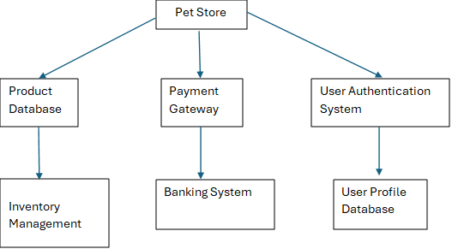

**Mind Map:**

